SHADOW TESTER v1.0
User’s Guide
ShadowTester is a program that lets you take screenshots automatically of one or more processes that must be specified.
The program consists of 3 files that must be located in the same directory of your computer. These files are:
- Shadowtester.exe
- ShadowTester.dll
- CommandLine.dll
In the image below you can see how the 3 files have been located in C:\PGP.
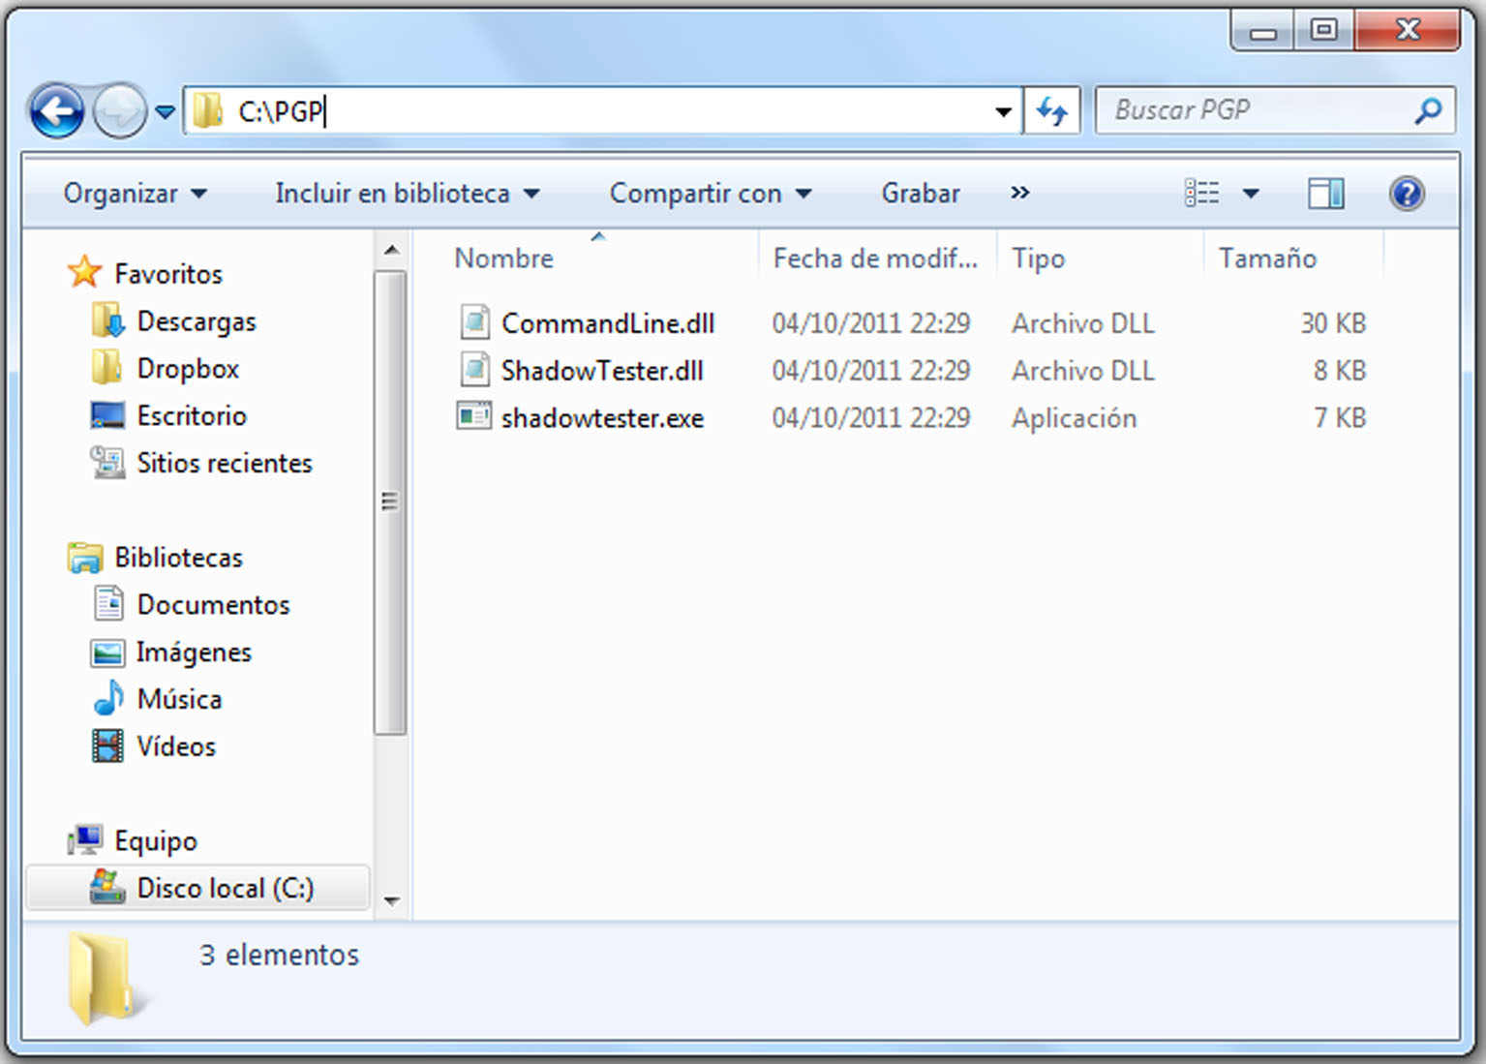
Once this is done, you must open the Console so you can run the program:
Start – Run – cmd
Now we type ‘cd’ followed by the name of the directory where we saved the program files.
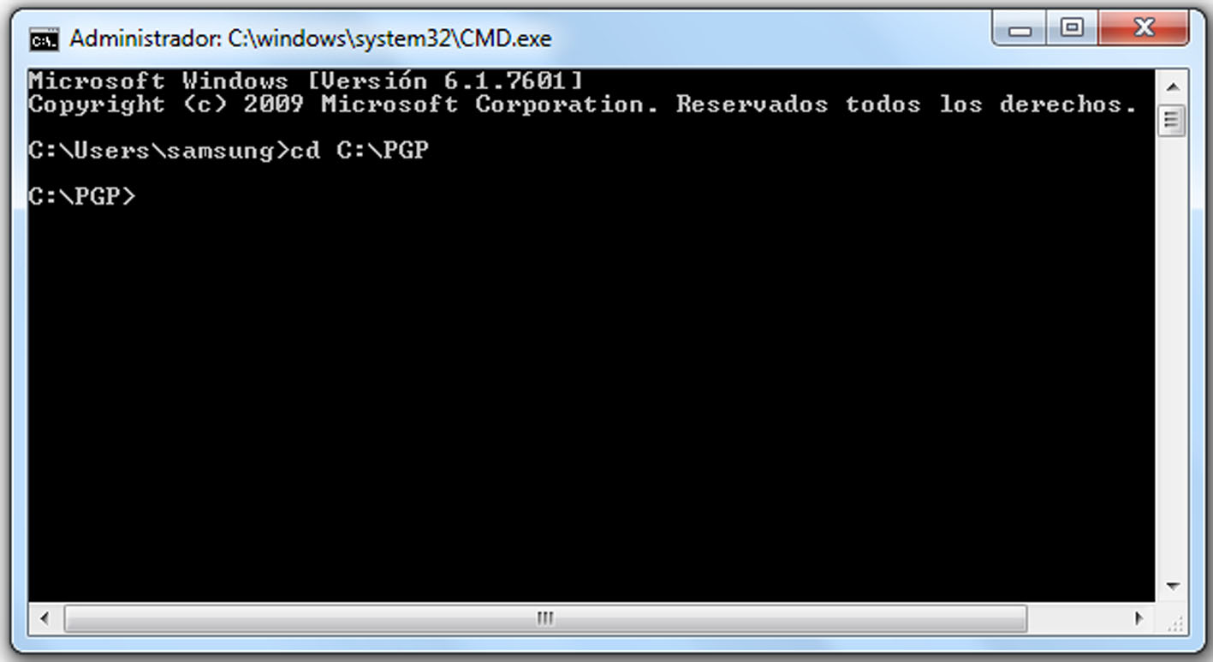

To start you should type ‘shadowtester’. You will see the syntax you have to use to run the program correctly.
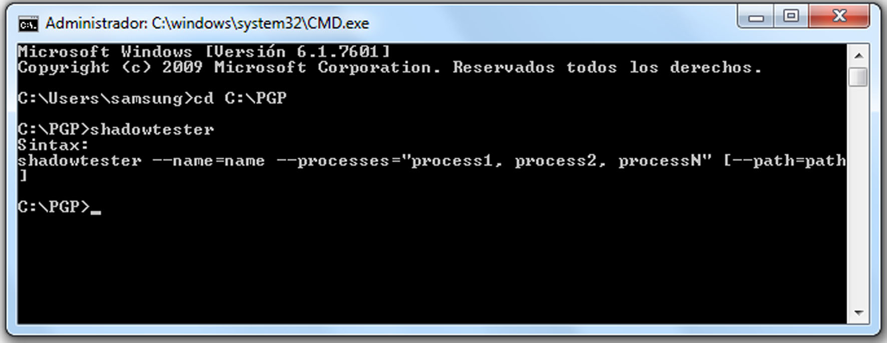
As you can see in the image above the correct syntax is:
shadowtester --name=name --processes=”process1, process2, processN” [--path=path]
- name: name of the directory where the screenshots will be saved. By default, it will be created in the current path.
- processes: list of the processes you want to capture.
- path: path of the directory where the screenshots will be saved. This is an optional parameter.
According to the syntax, this is an example of a correct command to run the program:
shadowtester --name="Grabacion1" --processes="firefox, iexplore"
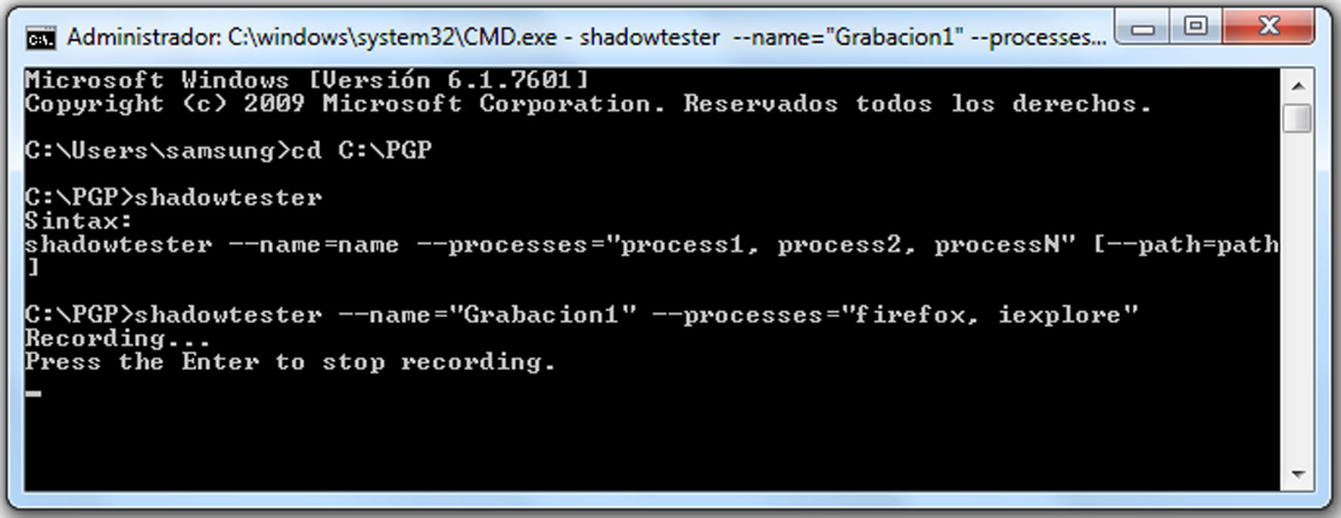

The program has started taking screenshots. From this moment on, it will take screenshots every time the specified processes (iexplore and firefox) are in the foreground window. The screenshots will be saved in a directory called ‘Grabacion1’ in the current path (C:\PGP).
To stop the program you have to press the Enter key.
You can check that all the screenshots have been taken and saved correctly.

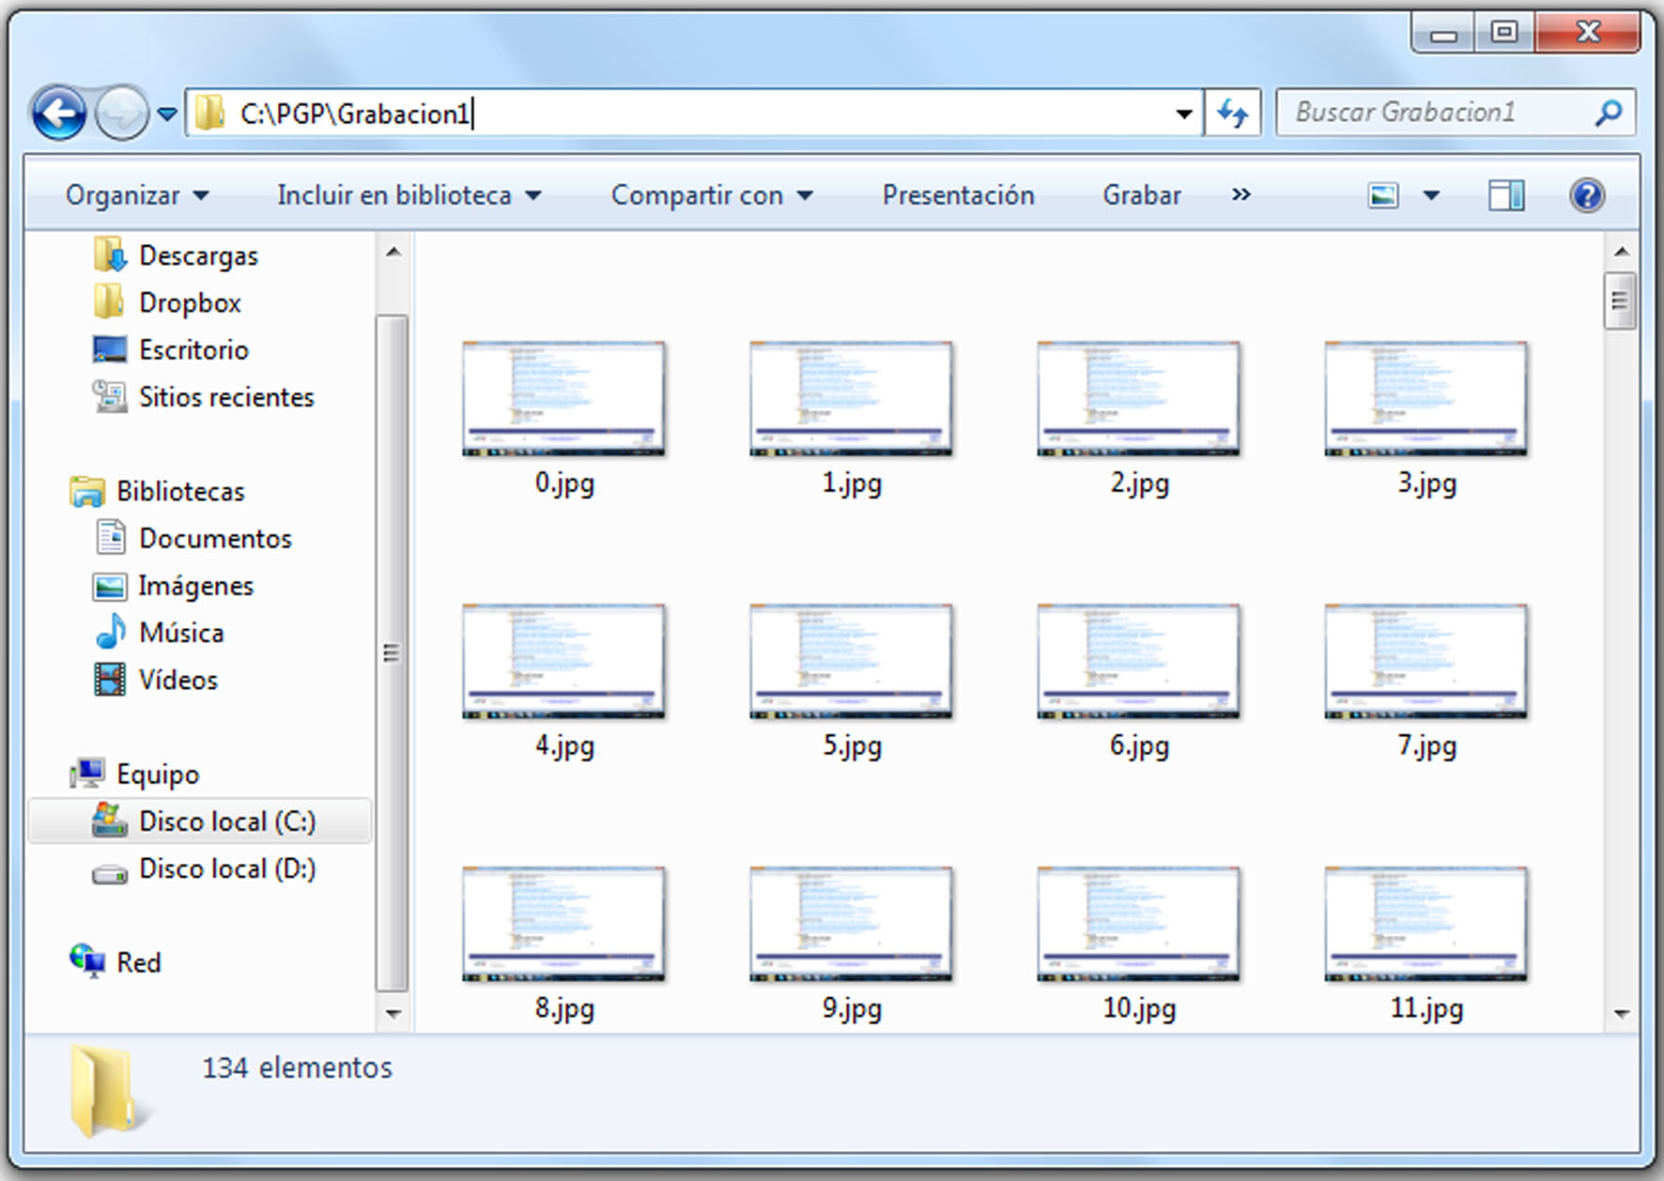

Thanks to the optional parameter --path you can specify a different path to save the screenshots.
Let’s see an example using this optional parameter:
shadowtester --name="Grabacion2" --processes="firefox " --path=D:\pruebas
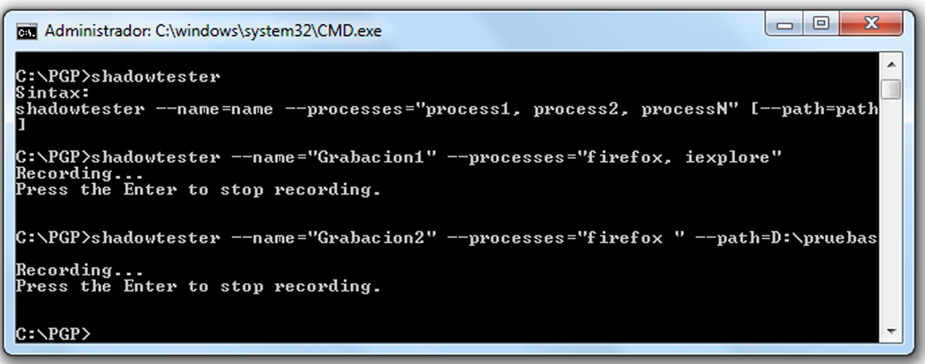
Now you can check that the directory has been created in the specified path and the screenshots have been saved:
